***Wellbeing Websites & Apps***

**Websites**

Begins to prepare young people for first visit to a GP about mental health

 <http://www.docready.org>

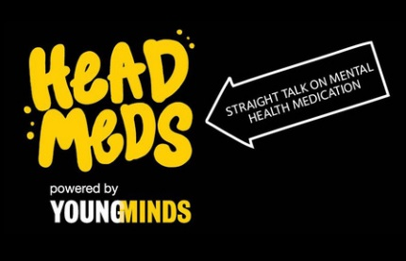 <http://www.headmeds.org.uk>

Extremely useful Info for young people on medication, mental health and life

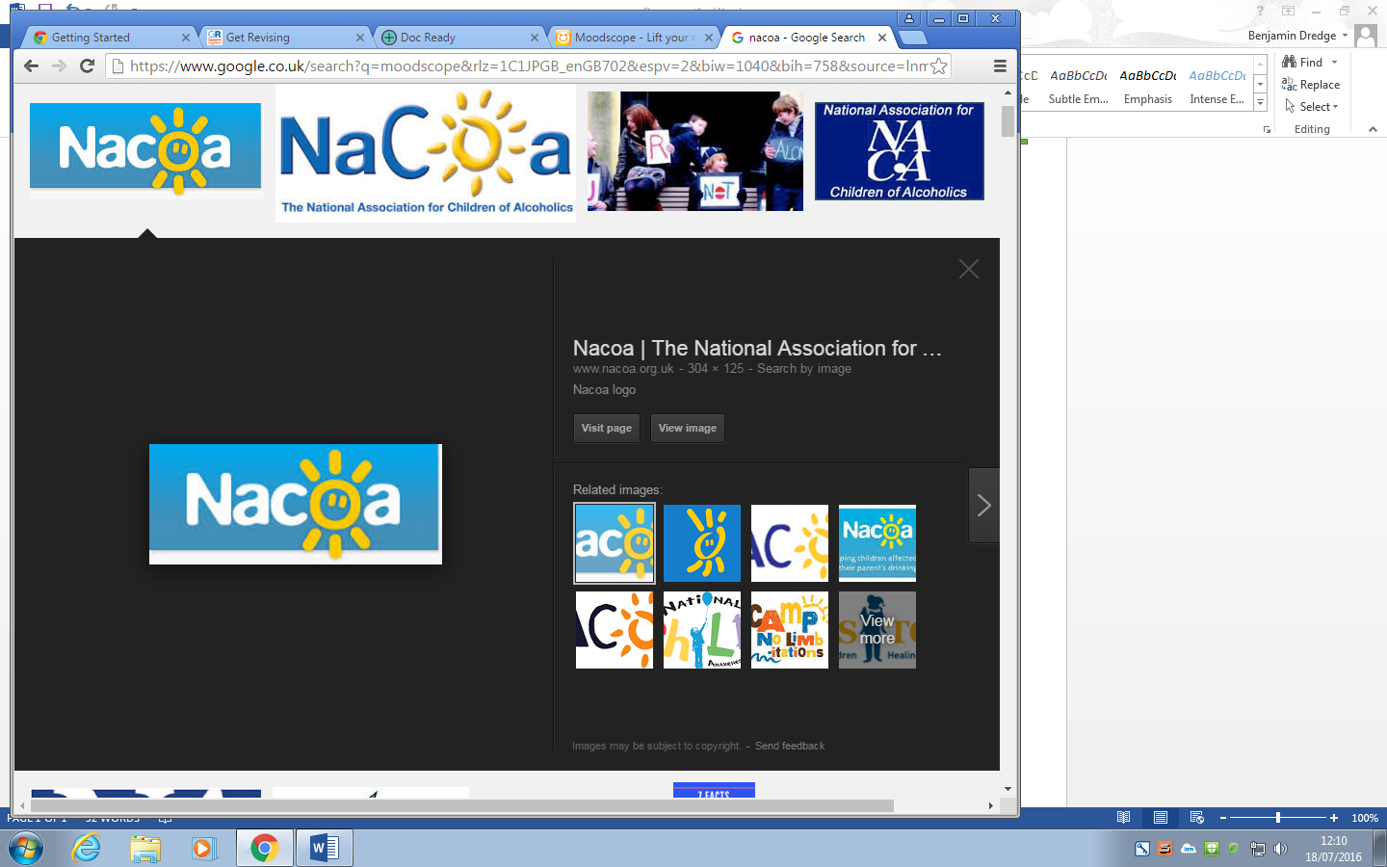 <http://www.nacoa.org.uk/>

Nacoa is an information and support for children and young people who are affected by a parents drinking

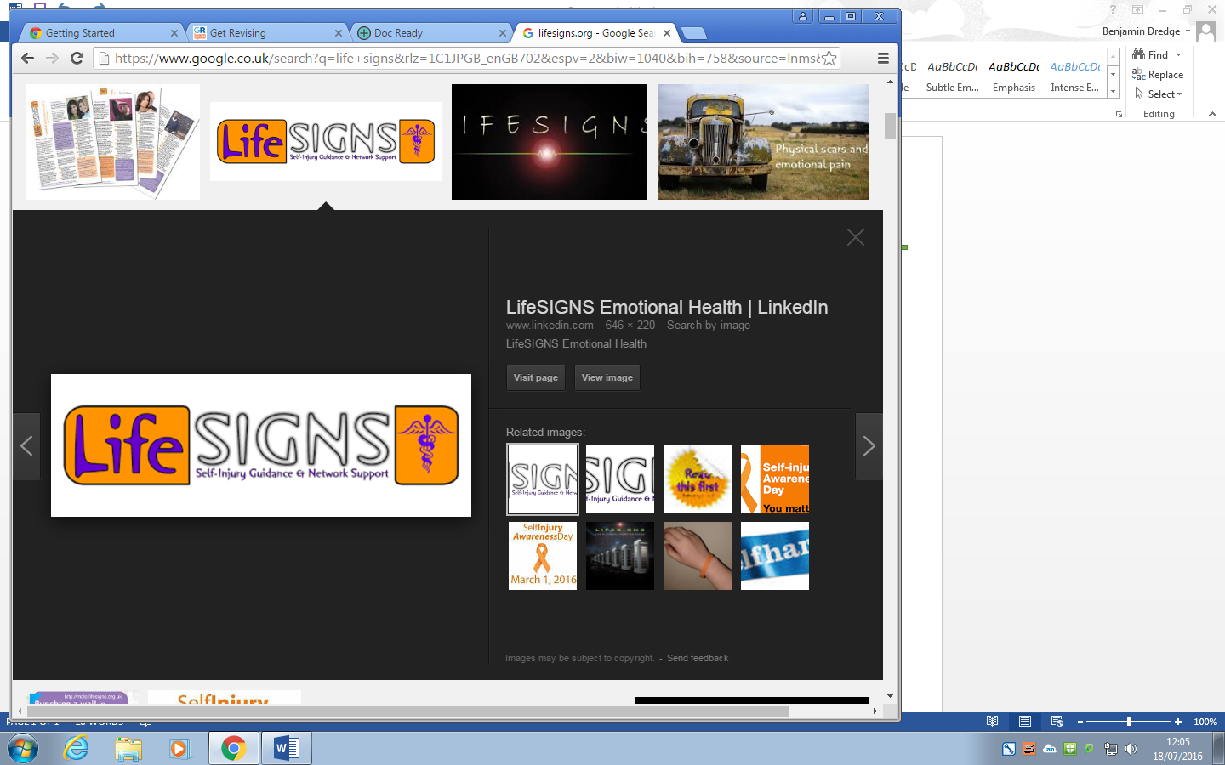 <http://www.lifesigns.org.uk/>

Info and support around self -harm

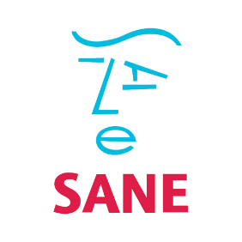 http://www.sane.org.uk/

Sane provides lots of info mental health, as well as telephone, email and text support, and an online forum

Caring for others is important so this website helps those you know who suffer from self-harm. Information for professionals and young people about self-harm.

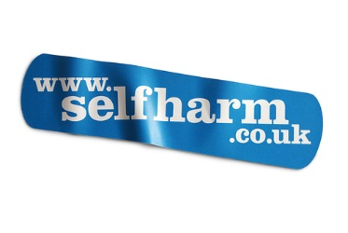 <http://www.selfharm.co.uk>

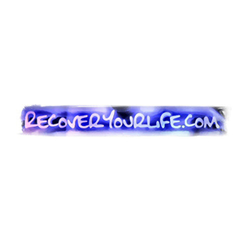 <http://www.recoveryourlife.com>

OCD can ruin lives so this website provides information and support.

Observes your mood as a tracking tool. Basic version is free, but you can pay to get more in-depth features.

https://www.moodscope.com/img/logo.png <https://www.moodscope.com>

 <http://www/nightline.ac.uk/>

Listening service for students, provided by trained student volunteers

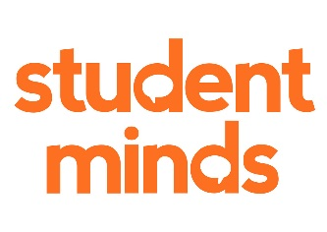 http://www.studentminds.org.uk

UK student mental health charity. Campaigns and peer support groups in universities across the country.

Information, advice and real life stories, specifically for students struggling with depression.

 <http://studentagainstdepression.org/>

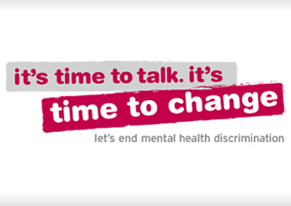 http://www.time-to-change.org.uk

Real life stories and information.

Information on mental health and wellbeing for young people, parents and professionals

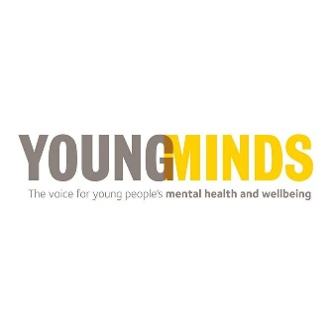 <http://www.youngminds.org.uk/>

**Apps: meditation**

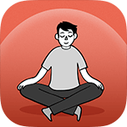 Stop, Breathe and Think

Guide to meditation, recommends certain meditations based on how you’re feeling

**Apps: Anxiety**

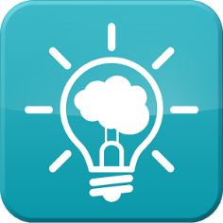 MindShift

Specifically for young people to help manage anxiety. Lots of tools, techniques and advice

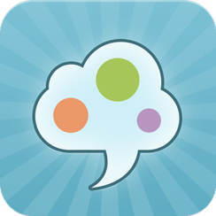SAM (Self-help for anxiety management)

Helps with anxiety management. Interactive games and tools, and anxiety tracker.

**Apps: General**

InHand

App to help young people through the ups and downs of life. Suggests activities to help based on how you rank your mood

HealthyMinds

Problem-solving tool aimed at students

Recovery Record

Self-help tool for eating disorders